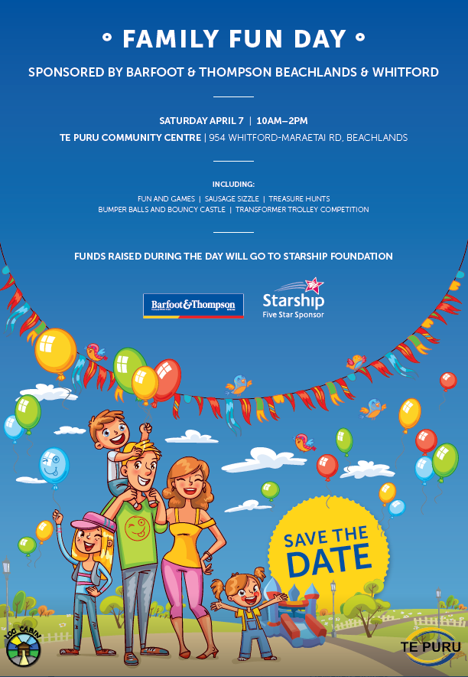 | 3 Legged Race  Bouncy Castle  Bumper Balls  Candy Floss  Cake Stall  Circuit  Coin Toss  Colouring Competition  Face Painting  Games Area  Golden Tickets  Gymnastics  Hospital Fancy Dress Parade  Kayaking  Kite Making / Flying  Limbo  Lost and Found  Obstacle Course  Paddle Boarding  Pizza  Play Dough  Popcorn  Potato & Spoon Race  Power Hooping  Rat Trap Throw  Sack Race  Sausage Sizzle  Shoot A Hoop  Sponge Game  Spot Prizes  Stake Your Claim  Treasure Hunt  Waterslide

