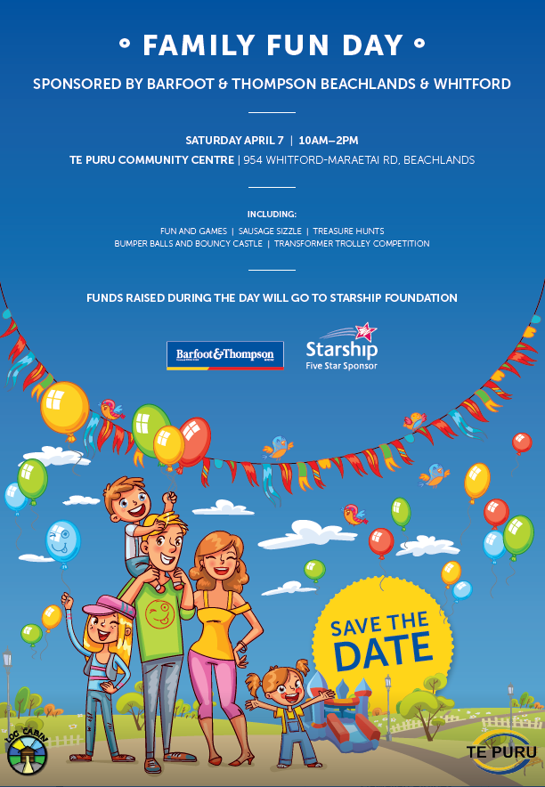  FUNDS RAISED DURING THE DAY WILL GO TO KIDZ FIRST AND STARSHIP FOUNDATION  FUN AND GAMES : SAUSAGE SIZZLE : TREASURE HUNTS : BUMPER BALLS  BUNGEE RUN : SOCCER : DARTS BLAST : ENTERTAINMENT BOUNCY CASTLES  SATURDAY MARCH 23 10 AM – 2 PM | Auction  3 Legged Race  Bouncy Castle  Bumper Balls  Candy Floss  Cake Stall  Circuit/Obstacle course  Coin Toss  Colouring Competition  Face Painting  Fire Engine and dress up  First Aid  Games Area  Golden Tickets  Gumboot throw  Gymnastics  Hospital Fancy Dress Parade  Kayaking  Kite Making / Flying  Limbo  Lost and Found  Paddle Boarding  Pizza  Play Dough  Police  Popcorn  Potato & Spoon Race  Power Hooping  Rat Trap Throw  Sack Race  Sailing  Sausage Sizzle  Shoot A Hoop  Sponge Game  Spot Prizes  Stilt race  Stake Your Claim  Treasure Hunt  Waterslide

